Assignment 1 Basic Knowledge

Released Date: September 12th

Version 1.0

Format: Name the document in the combination of name、ID and No. of Assignment.

**Example: Ping Yi_23_Assignment1.doc**

**Email the document to “pingy@wxit.edu.cn” before September 18th.**

**Task 1** Describe the MCU chip on the board of **Arduino Uno,** name **the type、number of pins、footprint and the main functions?**

任务1 描述Arduino Uno板上的单片机芯片，说出其类型、引脚数、脚印和主要功能。

类型：ATmega328处理器，双列直插式

引脚数：数字I/O引脚14个，模拟输入引脚 6

脚印：数字I0脚 1；模拟输入脚，电源引脚，各个输入输出脚

主要功能：通过引脚从外部接收信号；

通信（串行；WiFi）

**Task 2** Two LEDs are respectively linked with the **digital pins of D11 and D12**, make code to let them both **blinking every second**.

任务2 两个LED分别与D11和D12的数字引脚相连，编写代码让它们每秒钟闪烁一次。



Fig 1 Blinking Duo

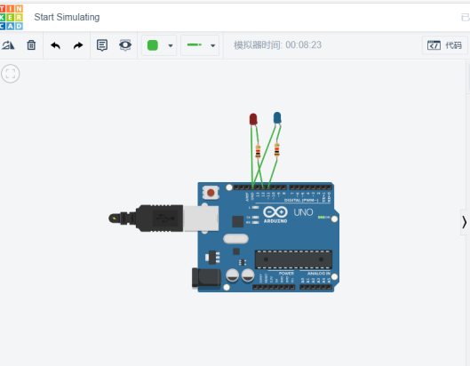

// C++ code

//

/*

This prodram pin 13 of the Arduino (the built-in LED)

/*

void setup()

{

pinMode(11,OUTPUT);

pinMode(12,OUTPUT);

}

void loop()

{

digtalWrite(11,HIGH);

digtalWrite(12,HIGH);

delay(100);